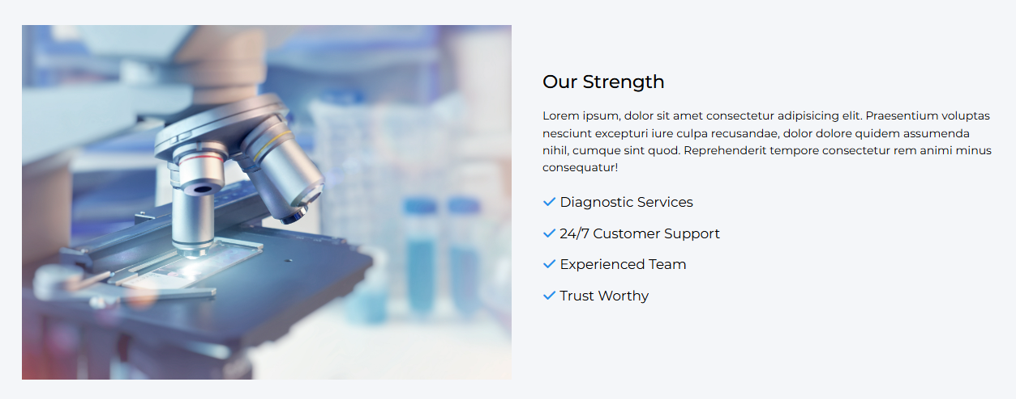
- In this section please remove dummy text with valid text.

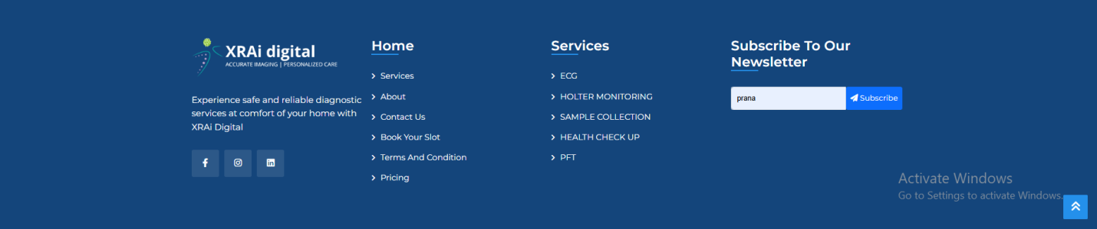
- In footer at the end please add (A unit of u4rad technologies pvt. Ltd.)


- Please add partners name with logo(As Razor Pay is considering this as dummy image.)

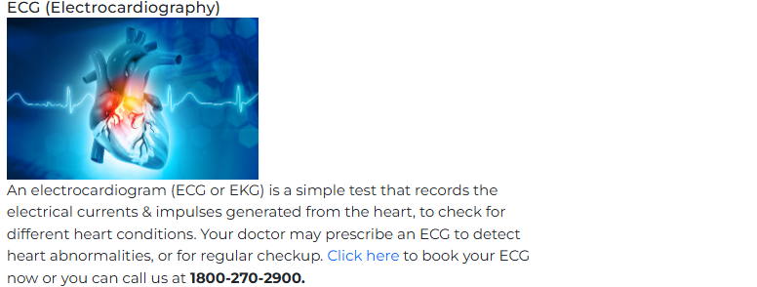
- In service section every Click here button should redirect user to login page.

